**Configuring to Enable Remote Access Through Remote Desktop**

**Time Required:** Approximately 10 minutes

**Objective:** Enable access to Windows Server 2016 through Remote Desktop.

**Description:** In this activity, you configure Windows Server 2016 to be accessed from Windows workstations, such as Windows 10, through Remote Desktop and using NLA.

1. Open **Server Manager**, if it is not open.
2. In the left pane, click **Local Server**.
3. In the right pane, click the setting for Remote Desktop, such as **Disabled** (if it is enabled already, click **Enabled**).
4. In the System Properties dialog box with the Remote tab displayed, ensure that **Allow remote connections for this computer** is selected as well as **Allow connections only from computers running Remote Desktop with Network Level Authentication recommended)**, if it is not already selected

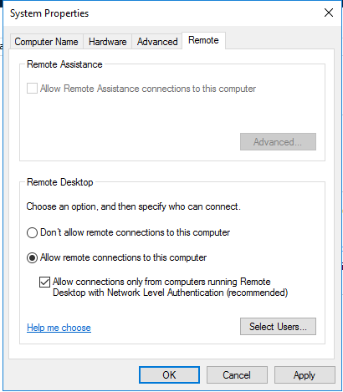

1. Click **Select Users**.
2. Click **Add in the Remote Desktop Users** dialog box.
3. In the Select Users or Groups dialog box, click **Advanced**.
4. Click **Find Now**.
5. Click the **Administrator** account or the account you are using (or press and hold **Ctrl** and click all of the accounts to have access).
6. Click **OK**. (If you see an error box, click **Close**. This may be a programming error to be fixed in an update, but it is likely to still add the account or group you selected.)
7. Click **OK** again in the Select Users or Groups dialog box.
8. Click **OK** in the Remote Desktop Users dialog box.
9. Click **OK** in the System Properties dialog box.
10. In the right pane of Server Manager, click the setting for **Windows Firewall**, which should be Domain: **On**.
11. Click **Allow an app or feature through Windows Firewall**.
12. Ensure the boxes are checked for **Remote Desktop** and for **Windows Remote Management** (including checks in their Domain, Private, and Public boxes), if they are not checked.

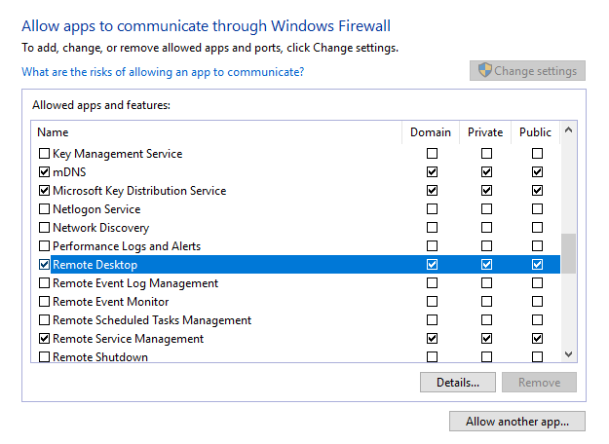

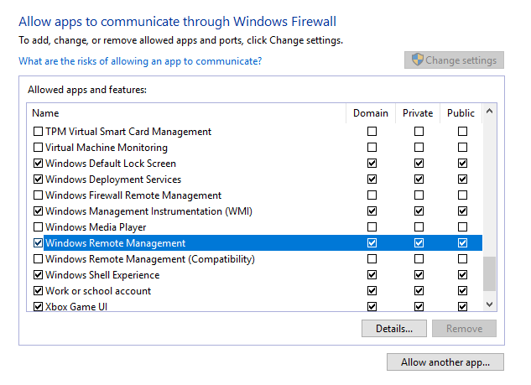

1. Click **OK** in Allowed apps window. Close Windows Firewall.